

**Project Title**

Inventory Forecasting for E-Commerce

**Course Title**

Optimization Modeling for Business Decisions

**Submitted To**

Prof. Arti Deo

**Submitted by**

Group 1

NMIMS, MBA (Digital Transformation), Division B

|  |  |  |
| --- | --- | --- |
| **NAME** | **ROLL NUMBER** | **SAP ID** |
| Srushti Jagwani | B004 | 80662400119 |
| Amisha Aggarwal | B014 | 80662400182 |
| Ishika Rupareliya | B024 | 80662400132 |
| Ansh Kumar | B034 | 80662400152 |
| Prajay Singh | B044 | 80662400163 |
| Ashwin Kumar Gondi | B054 | 80662400047 |
| Vaibhav | B064 | 80662400091 |

Table of Contents

Introduction 3

Objective 3

Identification of Issues 3

Methodology 4

Analysis 5

1. Toys Stock 5

2. Health Beauty Stock 7

3. Bed Bath Stock 8

4. Sports Leisure Stock 9

5. Furniture Decor Stock 11

Strategic Recommendations 12

Performance Implications 13

Results and Conclusion 14

References 15

# **Introduction**

This project focuses on forecasting inventory for an e-commerce platform by leveraging historical sales data. Effective inventory forecasting is critical in e-commerce to maintain optimal stock levels, reduce operational costs, and enhance customer satisfaction. This project applies various fore-casting techniques like Moving Average, Weighted Moving Average, Exponential Smoothing, Double Exponential Smoothing, and ARIMA so that the unit sales in 5 key categories can be correctly predicted like Toys, Health & Beauty, Bed & Bath, Sports & Leisure, and Furniture & Decor. These 5 categories form nearly 85% of the products out of total categories sold.

The revenue is estimated by calculating the average product price and then multiplying it with the number of units of each category. Such a method is deployed to approximately estimate revenue based on inventory predictions. The performance of the models is evaluated using : Mean Absolute Error (MAE), Mean Squared Error (MSE), and Mean Absolute Percentage Error (MAPE), and finally, leads to selection of a model with the least MAPE.

## **Objective**

This project aims to create a precise framework for forecasting inventory and revenue requirements that supports data-driven decision-making for better inventory management and ensures reliable revenue projections in alignment with demand patterns.

# **Identification of Issues**

1. Data Quality Issues: Missing or inconsistent data points, such as gaps in timestamps or product information, may affect forecasting accuracy.

2. Seasonality and Trends: The e-commerce website has seasonality, as well as changing patterns of demand. Models that do not capture seasonality may create predictions that have low accuracy.

3. External Influences: Variables like economic shifts, holiday seasons, or unforeseen events (e.g., supply chain disruptions) can affect demand unpredictably, posing a challenge for historical data-based models.

4. Product Life Cycle Variability: There can be commodities, which have short life cycles or varying demand, so these create some problems for time-series models to produce accurate predictions.

5. Data Granularity: Aggregating data improperly (e.g., daily vs. weekly) could either obscure critical trends or add noise, impacting model performance.

6. Limited Historical Data: A very limited availability of historical data for new products or categories may limit model accuracy, mainly in methods like ARIMA and regression analysis.

# **Methodology**

**1. Data Collection:** The dataset comprises sales transactions related to e-commerce from January 2017 to August 2018, providing information regarding orders, items, customers, payments, and products.

**2. Data Extraction:** Tables pertinent to the study (Orders, Order Items, Customers, Payments, Products) were extracted with an emphasis on fields essential for forecasting purposes, includingorder_purchase_timestamp, price, and product_id.

**3. Data Cleaning and Preparation:** There has been various corrections for missing values, removal of duplicates, and consistency between the tables.

**4. Data Characteristics:**

•Time Range and Frequency: Data from January 2017 to August 2018 was collected in monthly aggregates to make sure of overall trends rather than day-to-day variation.

•Seasonality and Trends: Analysis of the data revealed seasonal trends or patterns driving demand like sales peaks during certain periods of the year and widely used products of each category.

**5. Product and customer attributes:** Product categorizations, customer purchasing patterns, and order delivery rates were all studied in determining demand.

**6. Forecasting Scope:**

• Total Units Forecasting: A forecast was generated for overall units sold across all categories, providing a high-level estimate of demand.

• Category-Level Forecasting: Both unit and revenue types of forecasts were made for the five largest product categories, namely Toys, Health & Beauty, Bed & Bath, Sports & Leisure, and Furniture & Decor. The revenue forecast made for these units was done as follows: the units forecasted were multiplied by the average price of each specific category product.

**7.Time Series Forecasting Techniques Application:**

• Moving Average and Weighted Moving Average: It is considered smoothing short-term variations and capturing real demand.

**8. Methods** that are performed to remove trends using minimal computation are Exponential Smoothing and Double Exponential Smoothing. ARIMA: Utilized to identify trends and seasonal patterns in categories characterized by significant temporal dependencies.

**9. Evaluation Metrics for Model Comparison:**

• Mean Absolute Error (MAE): Gives a simple measure of average prediction errors.

• MSE: It focuses on large errors, hence supports the discovery of major differences.

• Mean Absolute Percentage Error (MAPE): Measures model accuracy in percentage terms and can easily be used for cross-category and model comparability.

**10. Optimal Model Selection:** Each model performance has been evaluated using MAE, MSE, and MAPE. The best model in each category is the one that has the lowest MAPE score. Based on the model that best predicts inventory quantities, revenue is computed by fitting the units and averaging prices.

# **Analysis**

## **Toys Stock**

***Figure 1: Analysis of Toy Stock Across Months***

***Table 1: MAPE Values for different forecasting techniques***

|  |  |
| --- | --- |
| Name of Technique | MAPE |
| 3PMA | 14.21% |
| 3PWMA (0.5, 0.3, 0.2) | 12.79% |
| Single Exponential Smoothing (α = 0.775) | 15.47% |
| Double Exponential Smoothing (α = 0.103, β = 0.431) | 11.27% |
| ARIMA(1, 2, 1) | 11.00% |
| ARI(1, 1) | 11.22% |
| Regression | 20.05% |

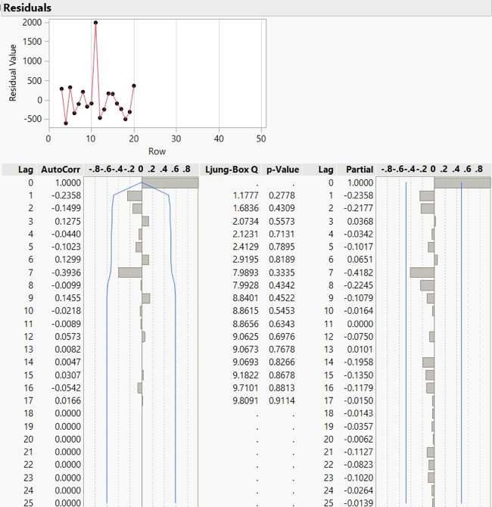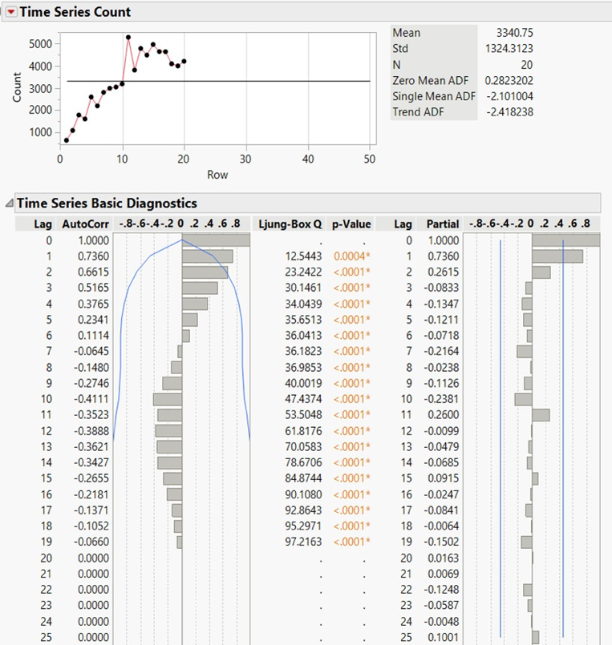

***Figure 2: ARIMA Results for Toys***

For forecasting the Toys count, the **ARIMA (1, 2, 1)** model achieves the lowest MAPE of 11.00%, indicating it is the most accurate method. It effectively captures both trend and seasonal components particularly useful with count data that may well feature periodic demand patterns. This makes ARIMA (1, 2, 1) the best model to predict the quantities of toys as it gives a reliable basis for inventory planning and stock management.

• Average Price = ₹340.905639

• Predicted Stock = 3813.6313174145

• Revenue = 340.905639 × 3813.6313174145 ≈ ₹1,300,088.42

## **Health Beauty Stock**

***Figure 3: Analysis of Health Beauty Stock Across Months***

***Table 2: MAPE Values for different forecasting techniques***

|  |  |
| --- | --- |
| Name of Technique | Stock count MAPE |
| 3PMA | 19.66% |
| 3PWMA (0.5, 0.3, 0.2) | 16.96% |
| Single Exponential Smoothing (α = 0.809) | 18.62% |
| Double Exponential Smoothing (α = 0.808, β = 0.0003) | 15.65% |
| IMA(1, 1) | 16.64% |
| IMA(2, 2) | 16.87% |
| Regression | 23.64% |

The minimum MAPE of 15.65% is obtained by the **Double Exponential Smoothing model**, with α = 0.808 and β = 0.0003. This also means that the most accurate technique is DES for predicting stock levels of health and beauty products. DES accurately captures short-term patterns and adapts the forecasts to any shift in demand, which is important for managing inventory in the Health & Beauty group where demand might be changing. This accuracy makes DES the best choice for the accurate forecasting of stock levels to support effective inventory management.

• Average Price = ₹340.87895163812

• Predicted Stock = 187.881114750413

• Revenue = 340.87895163812 × 187.881114750413 ≈ ₹64,044.72

## **Bed Bath Stock**

***Figure 4: Analysis of Bed Bath Stock Across Months***

***Table 3: MAPE Values for different forecasting techniques***

|  |  |
| --- | --- |
| Name of Technique | Stock MAPE |
| 3PMA | 22.73% |
| 3PWMA (0.5, 0.3, 0.2) | 21.51% |
| Single Exponential Smoothing (α = 0.77) | 25.38% |
| Double Exponential Smoothing (α = 0.238, β = 0.429) | 19.24% |
| IMA(2, 2) | 18.60% |
| ARIMA(2, 1, 1) | 21.11% |
| Regression | 47.45% |

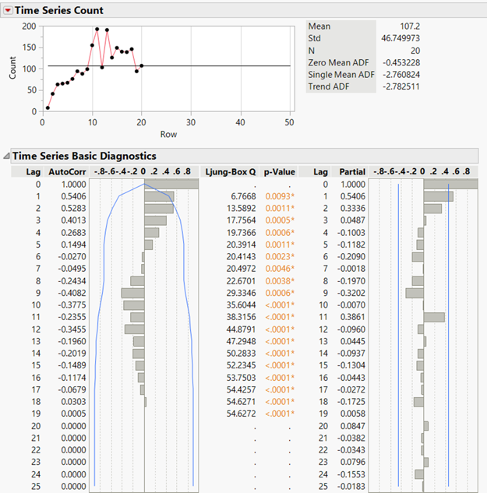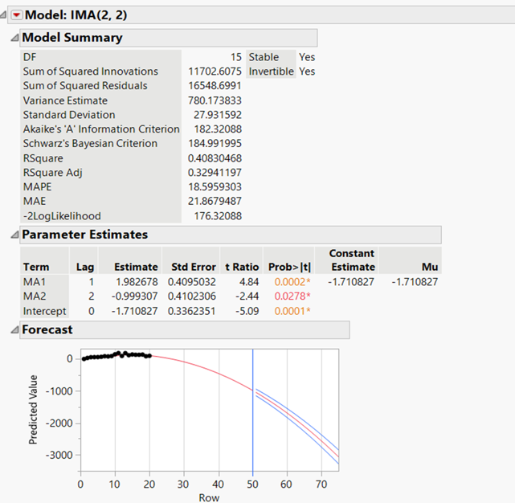

***Figure 5: ARIMA Results for Bed Bath Stocks***

The best performance was provided by the **IMA(2, 2) model** with a MAPE of 18.60%. This model effectively captures both trends and seasonality. Double Exponential Smoothing, with parameters α = 0.238, β = 0.429, closely follows with the MAPE 19.24% and thus provides a good balance between simplicity and accuracy. Regression is the most poorly performing method with MAPE as high as 47.45%. Overall, IMA(2, 2) is the best model for the forecasting of bed bath product stocks.

• Average Price = ₹340.882563705786

• Predicted Stock = 100.452821832116

• Revenue = 340.882563705786 × 100.452821832116 ≈ ₹34,242.62

## **Sports Leisure Stock**

***Figure 6: Analysis of Sports Leisure Stock Across Months***

|  |  |
| --- | --- |
| **Name of Technique** | **Stock MAPE** |
| 3PMA | 20.25% |
| 3PWMA (0.5, 0.3, 0.2) | 18.80% |
| Single Exponential Smoothing (α = 0.743) | 19.54% |
| Double Exponential Smoothing (α = 0.259, β = 0.395) | 16.97% |
| ARIMA(1, 1, 1) | 17.30% |
| ARIMA(2, 1, 1) | 16.85% |
| Regression | 30.50% |

***Table 4: MAPE Values for different forecasting techniques***

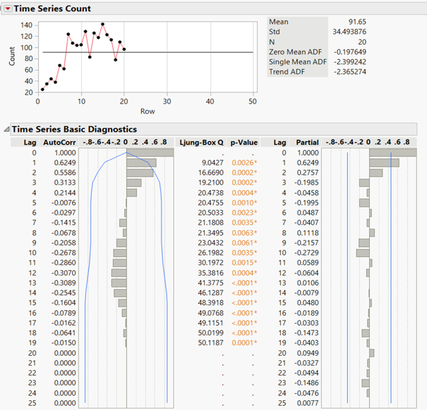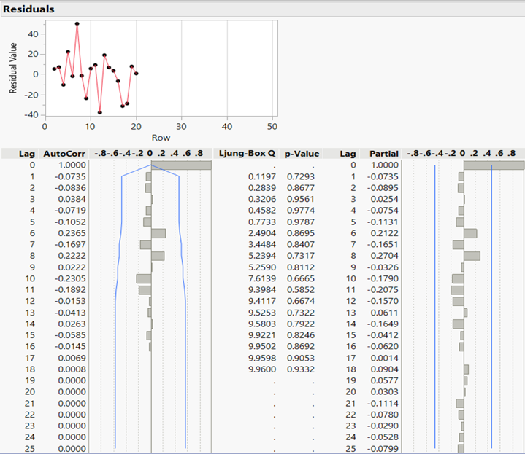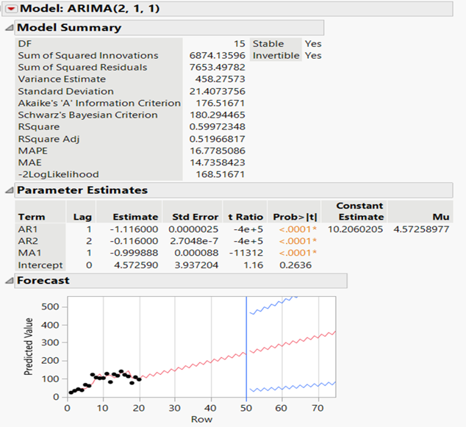

***Figure 7: ARIMA Results for Sports Leisure Stocks***

For stock forecasting, the **ARIMA(2, 1, 1) model** performs the best with a MAPE of 16.85%, making it the most accurate model for this category. It is closely followed by Double Exponential Smoothing (α = 0.259, β = 0.395), with a MAPE of 16.97%, showing good performance in capturing trends and seasonality. ARIMA(1, 1, 1) also performs well with a MAPE of 17.30%. 3PWMA (0.5, 0.3, 0.2) has a MAPE of 18.80%, which is slightly higher, but still decent. 3PMA is less effective with a MAPE of 20.25%, and Regression performs the worst with a MAPE of 30.50%, indicating it is not a suitable model for accurate revenue predictions in this case.

• Average Price = ₹340.970644727016

• Predicted Stock = 118.807366802736

• Revenue = 340.970644727016 × 118.807366802736 ≈ ₹40,509.82

## **Furniture Decor Stock**

***Figure 8: Analysis of Furniture Decor Stock Across Months***

***Table 5: MAPE Values for different forecasting techniques***

|  |  |
| --- | --- |
| Name of Technique | Stock MAPE |
| 3PMA | 21.94% |
| 3PWMA (0.5, 0.3, 0.2) | 22.72% |
| Single Exponential Smoothing (α = 0.207) | 20.91% |
| Double Exponential Smoothing (α = 0.181, β = 0) | 19.96% |
| IMA(1, 1) | 22.11% |
| Regression | 20.59% |

For Furniture & Decor stock forecasting, **Double Exponential Smoothing (α = 0.181, β = 0)** provides the best performance with the lowest MAPE of 19.96%, making it the most accurate model for stock predictions in this category. Single Exponential Smoothing (α = 0.207) follows closely with a MAPE of 20.91%, demonstrating reasonable accuracy. Regression performs slightly worse at 20.59%, while 3PMA (21.94%) and IMA(1, 1) (22.11%) are less effective, with 3PWMA (22.72%) showing the highest forecasting error.

• Average Price = ₹340.908857530566

• Predicted Stock = 97.6494198665543

• Revenue = 340.908857530566 × 97.6494198665543 ≈ ₹33,289.55

# **Strategic Recommendations**

1. Adoption of Average Price Revenue Estimation

Estimate using the average price and forecasted stock instead of placing the revenue forecast directly; this is an easy yet effective way to revenue predict. This will not be dependent on the complex revenue forecast models, and this ensures that revenue predictability is well placed on stock levels. This is considered as just-in-time revenue planning where it is simpler and adaptable in case of the real-time changes.

1. Enhanced Inventory Allocation for High-Demand Categories

Using the stock forecasts, select lines like Toys and Health & Beauty where the demand is high, thereby making the right decision regarding the size of the holding, thus ensuring that those items when in demand will not result in lost sales through stockouts and also improve cash flows. Thirdly, it supports strategic investment in categories with high revenue perpetually, hence improving profitability overall.

1. Risk Management Through Stock Level Optimization

With a solid average price-based estimate of revenue, appropriate risk management practices need to be built that account for fluctuations in demand. It would discern patterns in inventory and stock trends; thus, the business can request flexible supplier agreements and stock control measures to adjust the dynamic inventory, especially categories subject to seasonal or cyclical demand. This way, the business is protected from potentially overstocking or underequipping, which can further stabilize the business through demand swings.

1. Implementing a Forecast-Driven Alert System for Stock Levels

Implement a notification mechanism that utilizes stock forecasts to inform management about essential inventory thresholds, particularly in instances where stock levels are nearing exhaustion or surpassing ideal limits. This facilitates a proactive approach to fluctuations in supply and demand, enabling managers to monitor stock availability more effectively, thereby reducing the likelihood of surpluses or shortages. Consequently, this system enhances responsiveness to market demand, ultimately promoting customer satisfaction and ensuring a stable cash flow.

1. Model Calibration Based on Market Dynamics

As much as average prices are used in the approximation of revenues, do double-check sometimes how sharp the models are for forecasting stock, that is, DES, ARIMA, and what extent they can be fine-tuned to be relevant in terms of current trends for inventory forecasting closely related to the respective sales cycles and the market demand.

# **Performance Implications**

1. Improved Financial Predictability Through Stock-Based Revenue Estimation

With average price and stock levels, revenues become more predictable with the potential margins of error reduced in financial planning. This has resulted in more reliable budgets, fewer corrective measures, reduced holding at inventory, and hence stable financial performance and healthy profit margins.

1. Operational Efficiency through Optimized Stock Management

Inventory-optimized forecasting focuses on the effective balancing of stock levels with market demand to optimize operational efficiency. This eliminates excess stock-related financial costs and reduces storage costs. In addition, effective stock management ensures that customers receive the products at the appropriate time, thereby increasing customer satisfaction and reducing lost sales.

1. Increased Competitive Edge through Improved Inventory Responsiveness

The alert system, combined with optimized inventory levels, enables the organization to react promptly to market demands, representing a critical benefit within the e-commerce industry. This enhances the company's competitiveness in the marketplace, as consumers enjoy superior product availability and timely deliveries, consequently fostering greater brand loyalty and enhancing market positioning.

4. Enhanced Strategic Decision-Making for Long-Term Stability

More importantly, based on actual inventory and stock-based revenue estimates, the business can employ the most informed strategies for growth, such as investment in high-demand product categories, thereby reducing vulnerability to market and demand volatility and creating long-term resilience.

# **Results and Conclusion**

It is an updated method of forecasting which utilizes average price and stock quantity to estimate revenues and provides a simple and efficient technique in revenue prediction. This method can reduce complexity while providing full reliability to revenue forecasts for every category:

* Double Exponential Smoothing- Overall Stock Forecasting: DES succeeded in overall stock forecasting as well, with parameters (α = 0.238, β = 0.429) yielding a MAPE of 13.25%. This reflects its ability to capture the trend across all categories, giving stable forecasts based on levels of stock that will come in.
* In a specific category stock forecast, DES achieves the accuracy in terms of delivering low MAPE for Toys stock, while ARIMA dominates only in categories involving Health & Beauty stock forecast with 15.65% MAPE. Its adaptability helps to produce better accuracy in other categories too, which makes inventory allocation and customer satisfaction highly high.

This model simplifies the complexity of revenue forecasting but yet gives information-driven recommendations in the management and prioritization among categories through focusing on quantities in the study of inventory with regard to revenue estimation. Although this methodology does not include qualitative elements, like market trends, the inclusion of these elements is sure to solidify strategic planning far better. Lastly, this revised technique of forecasting makes it easy and efficient in revenue and inventory management, thereby positioning the business well to readily respond to market variability accordingly.

# **References**

1. <https://www.netsuite.com/portal/resource/articles/inventory-management/inventory-forecasting.shtml>
2. <https://www.shipbob.com/inventory-management/inventory-forecasting/>
3. <https://www.logiwa.com/blog/mastering-inventory-forecasting-for-online-retailers>
4. <https://www.netscribes.com/e-commerce-demand-forecasting-is-revolutionizing-inventory-management/>
5. <https://www.brightpearl.com/inventory-management-system/inventory-forecasting-methods>